Education:
Evangel University, B.A., Art major
Friends University, MBM, Management
Personal:
Married, four children. Cindra, wife, retired nurse, now trains show dogs. We own historic home in Bartow, FL
Art Experience:
Art Teacher, Middle and High School, 4-years in Ohio
Past President of the Lakeland Art Guild
Presenter, teacher, motivator for Watercolor Painting
Currently, Portrait Watercolor Painter
Art Recognition:
Signature Member, Florida Watercolor Society
Signature Member, Georgia Watercolor Society
Bronze, Tallahassee Watercolor Society Member Show
Best-in-Show, Ridge Art Assoc. City Hall Show
Best-in-Show, Ridge Art Assoc. Anniversary Show
2-years in Western Federation Watercolor Society Shows
Statement:
I took a beginner’s watercolor painting class in September of 2015. I was hooked. I have painted almost every day since. I tried many subjects and find portraits the most challenging, yet the most enjoyable to paint.
Much of my private studio time is spent experimenting with the many materials, styles and techniques watercolor painting offers.
My greatest “breakthrough” came after attending Ted Nuttell’s workshops. I created a color schematic of my paint palette and realized I had a vast array of colors, values and intensities available to me. At that point I was using maybe 10% of my palette’s potential.
My style today can be described in three words: realistic yet very colorful. I love holding workshops and sharing my approach to watercolor painting.

Recent paintings:
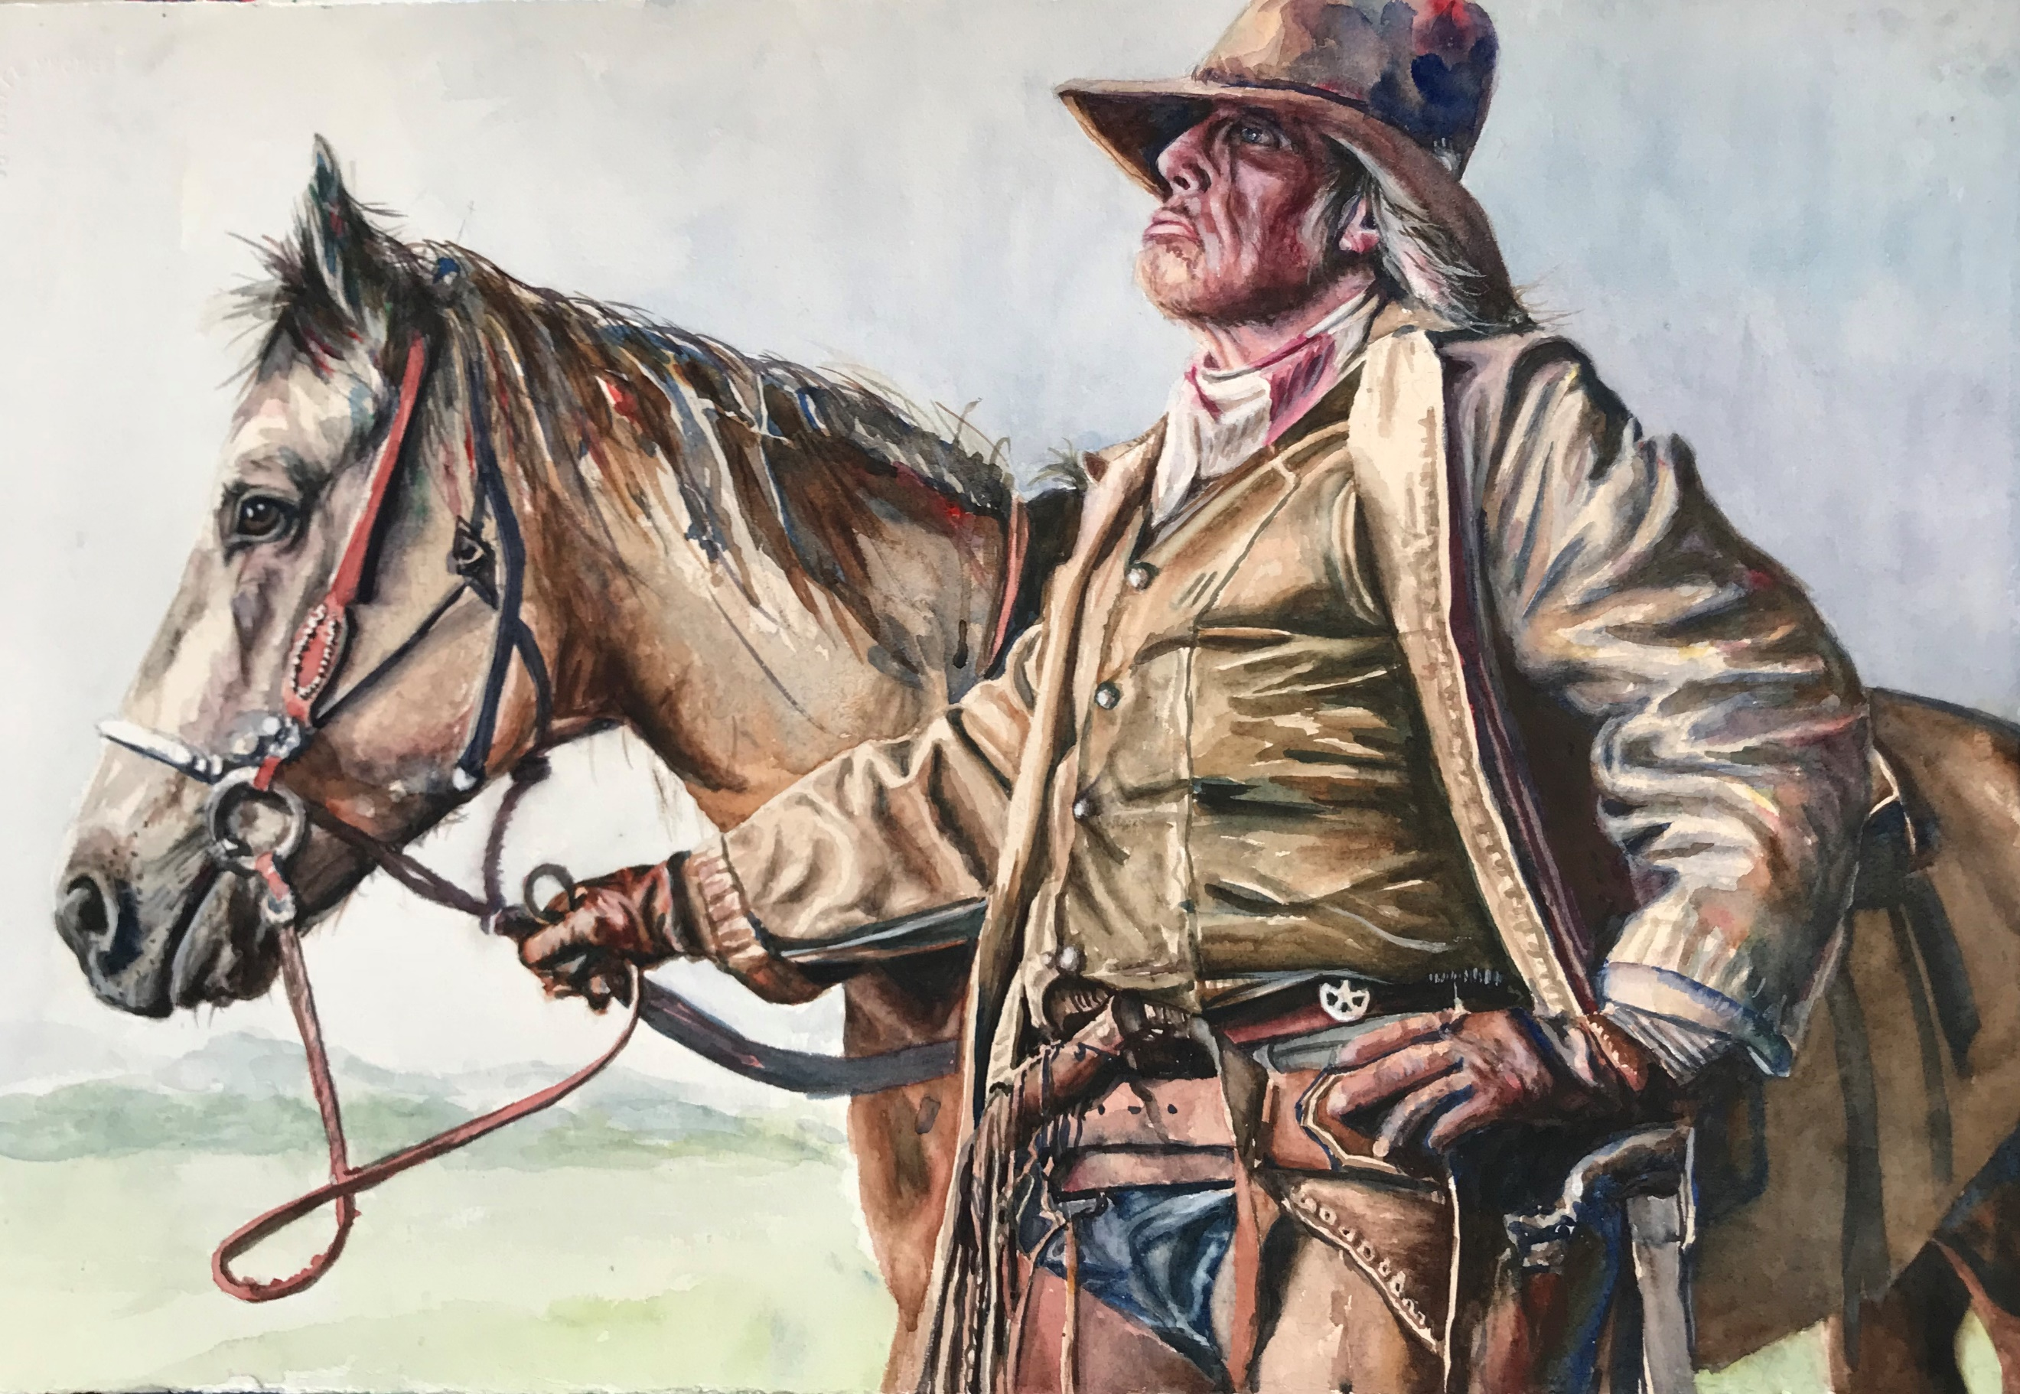
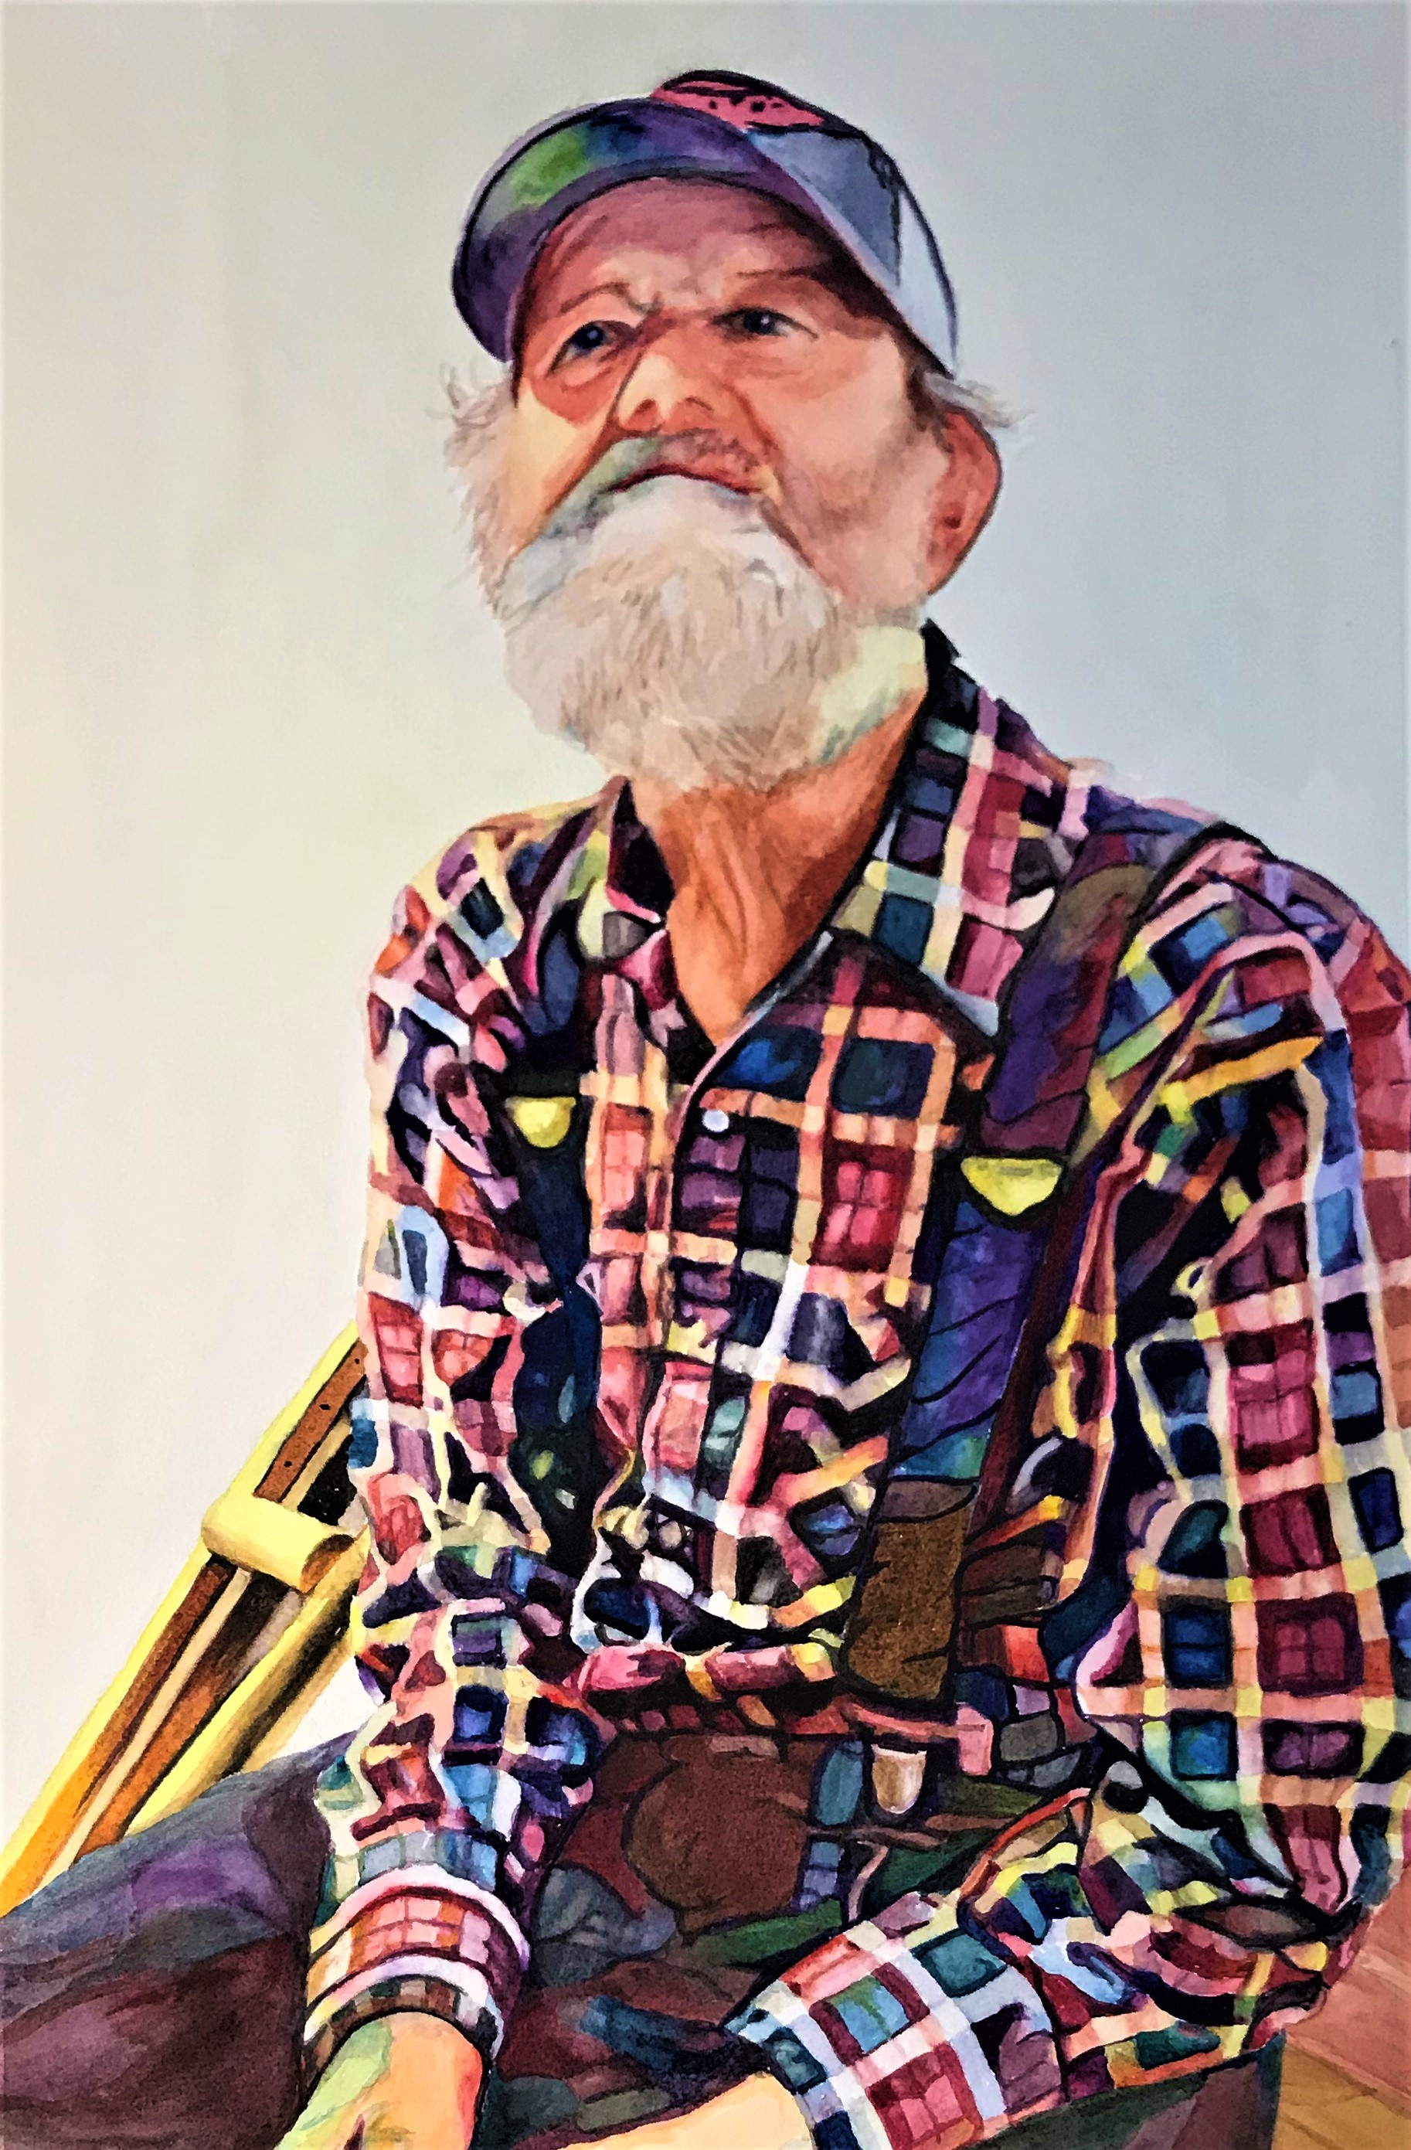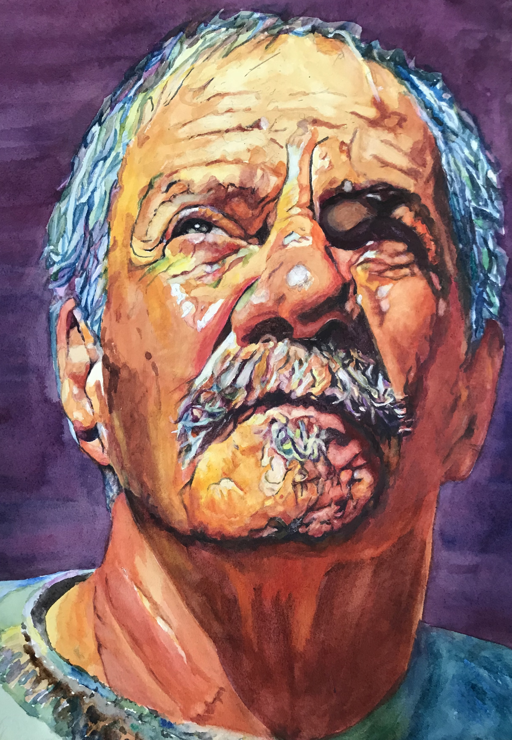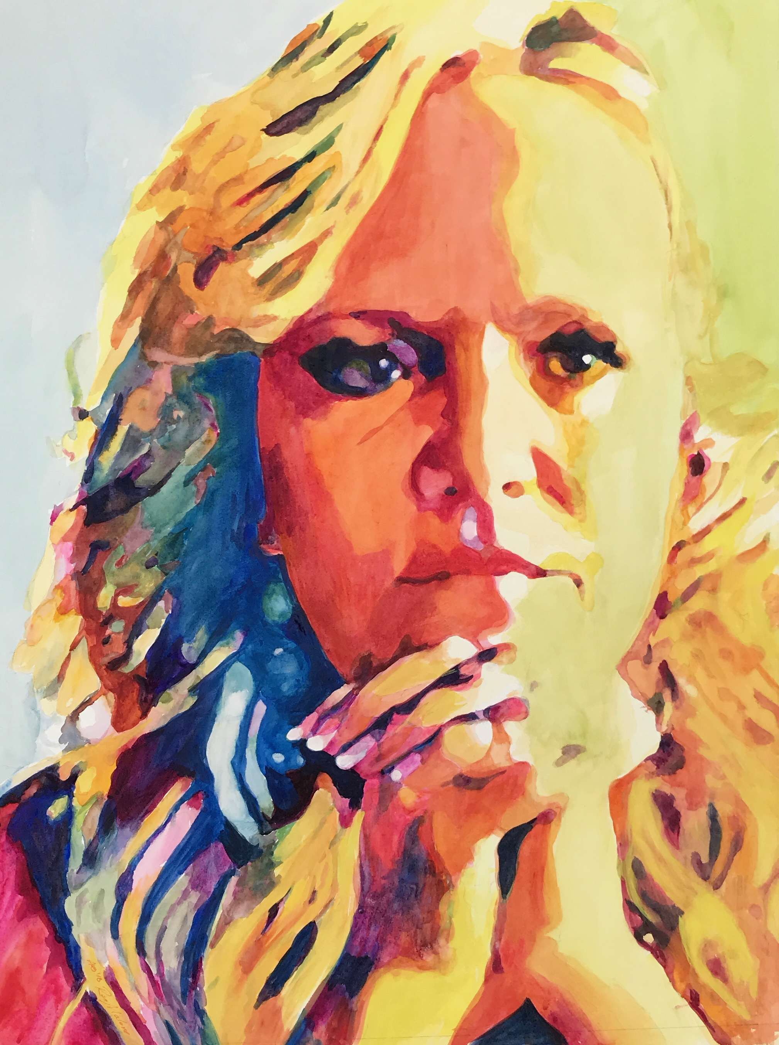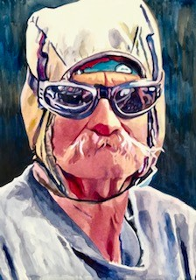
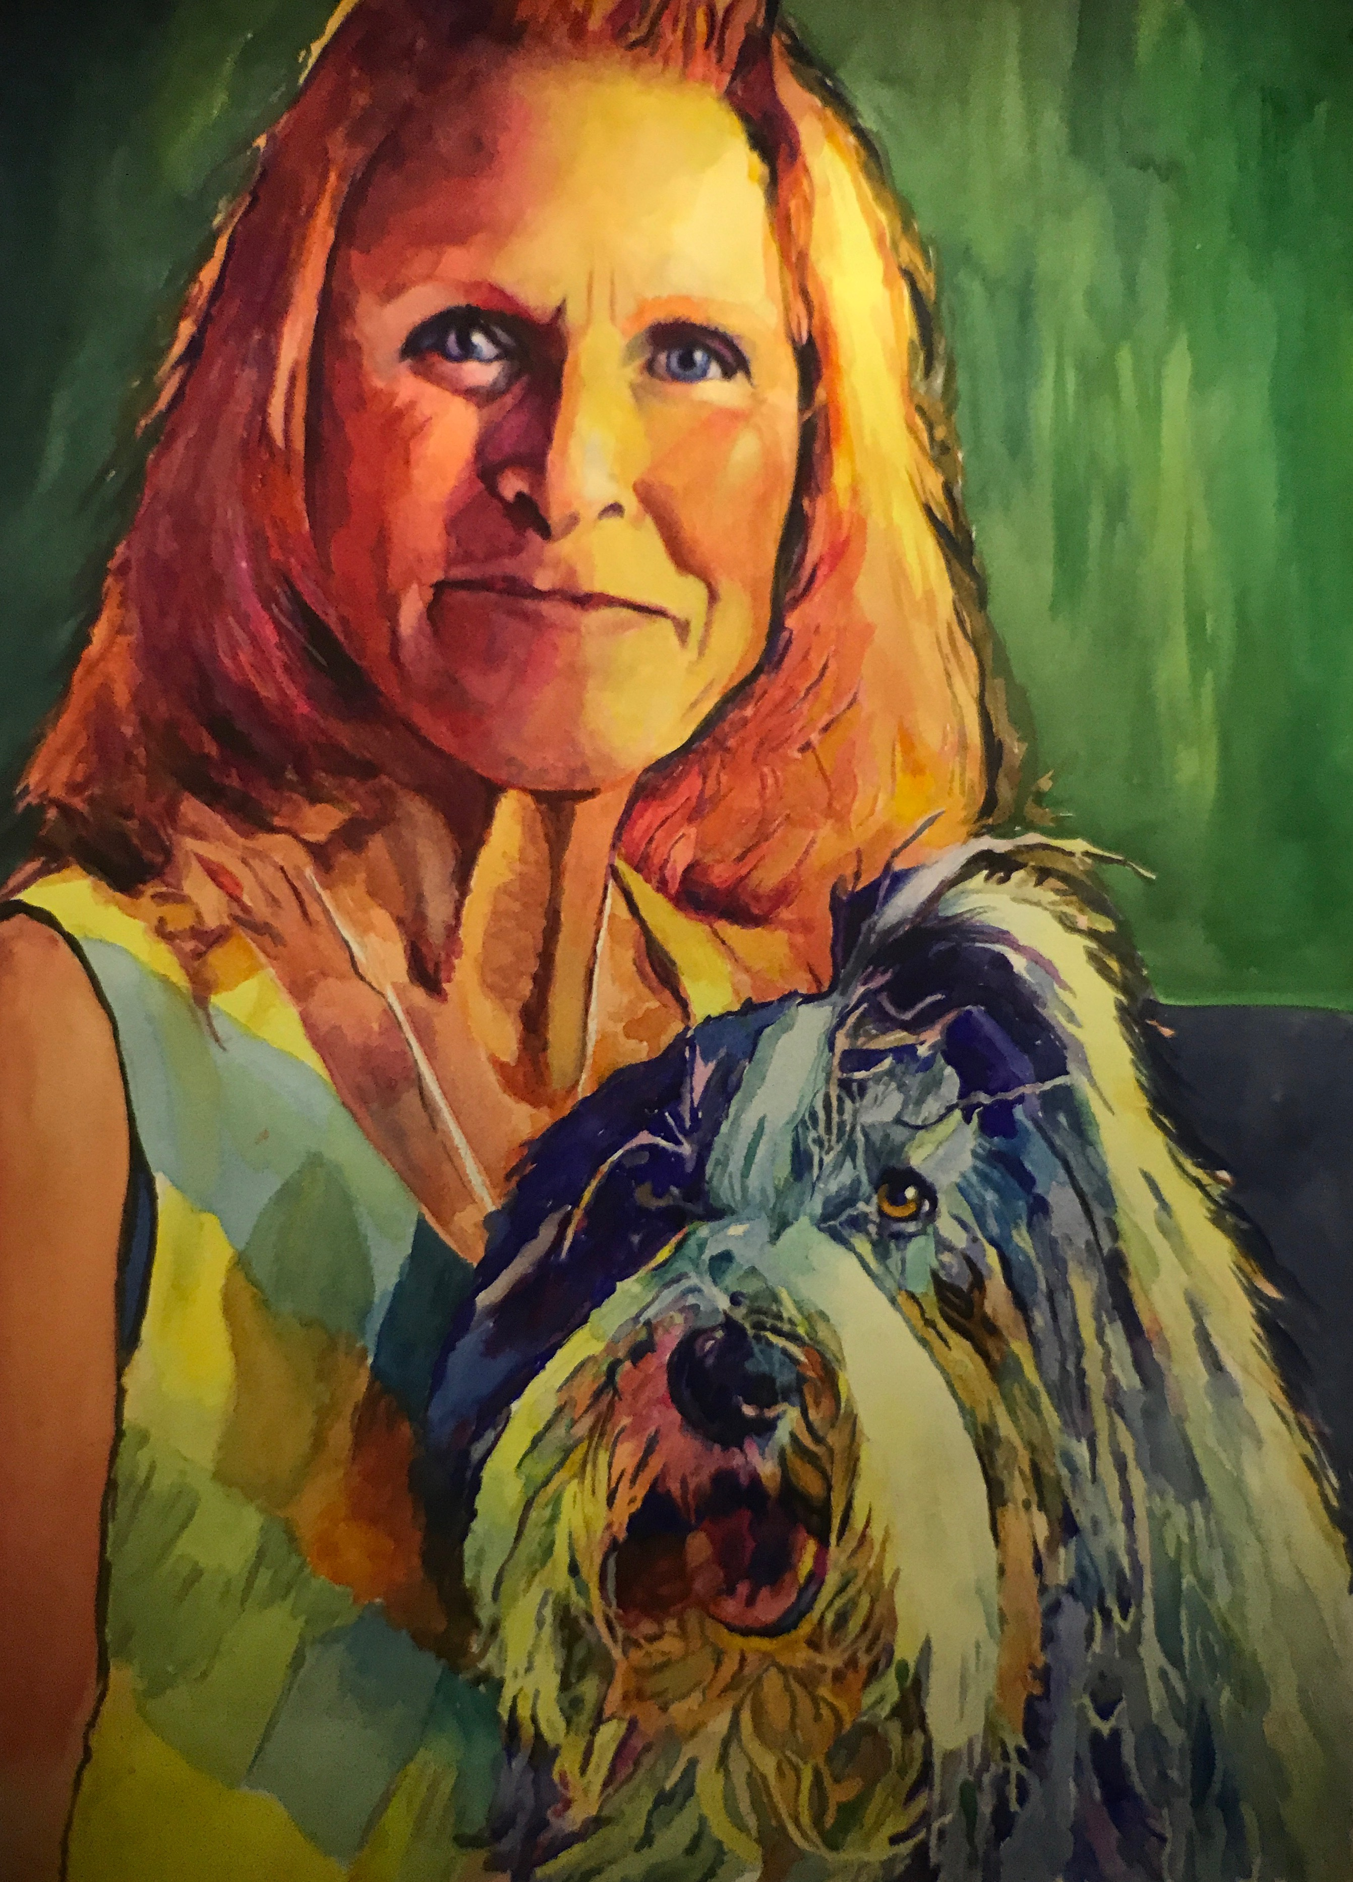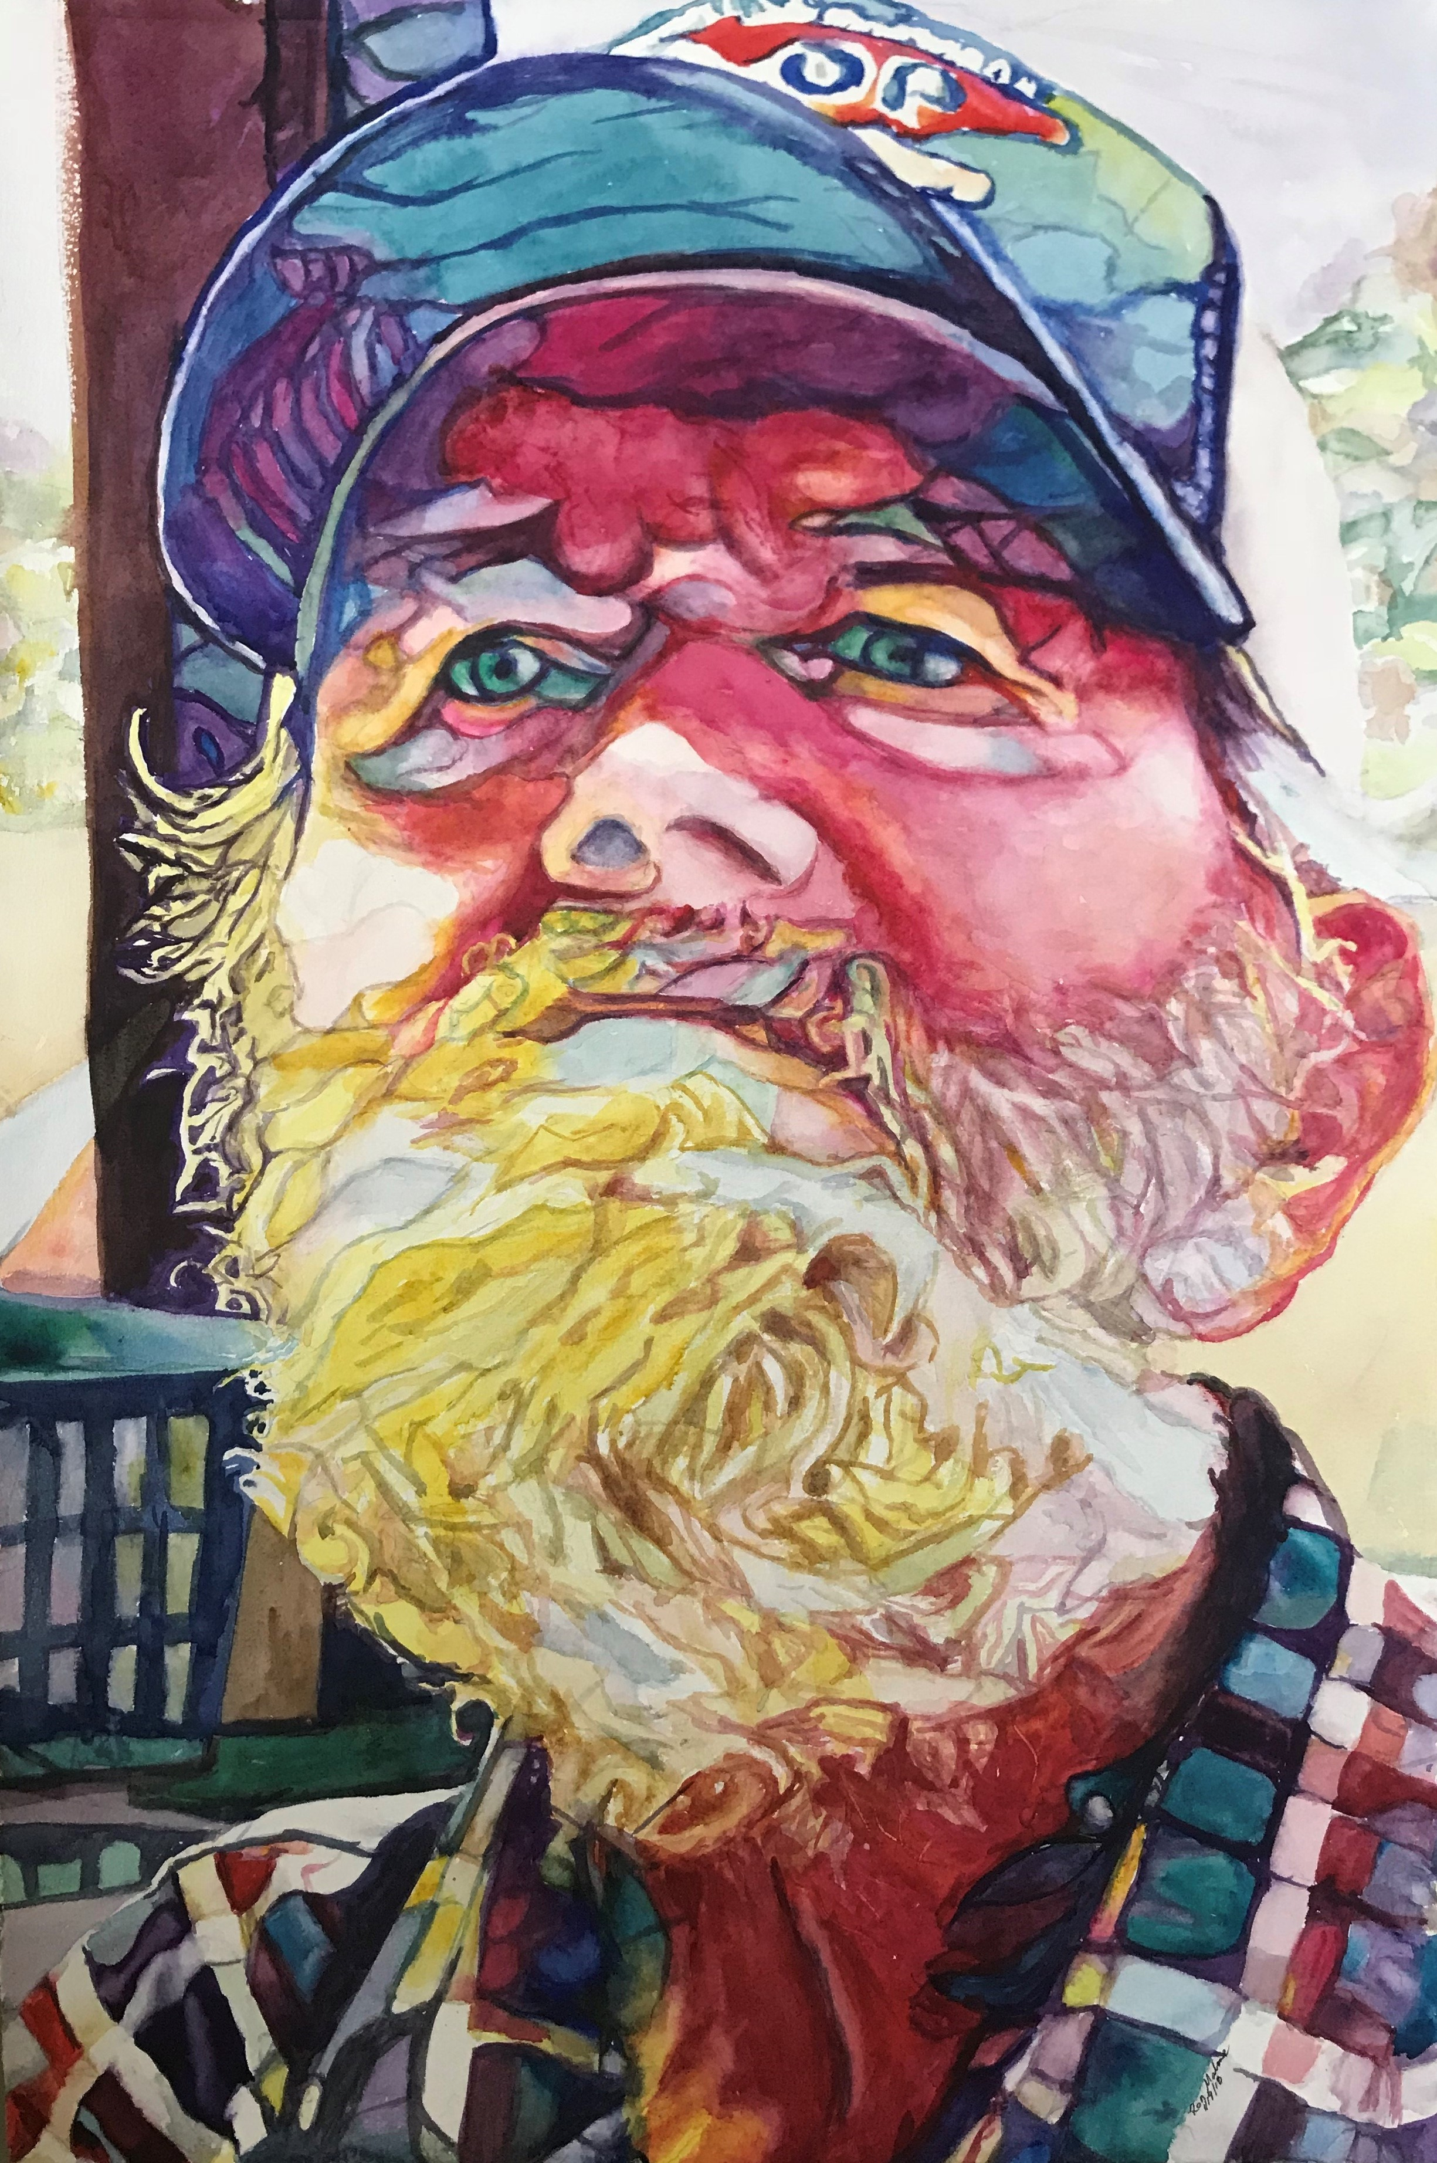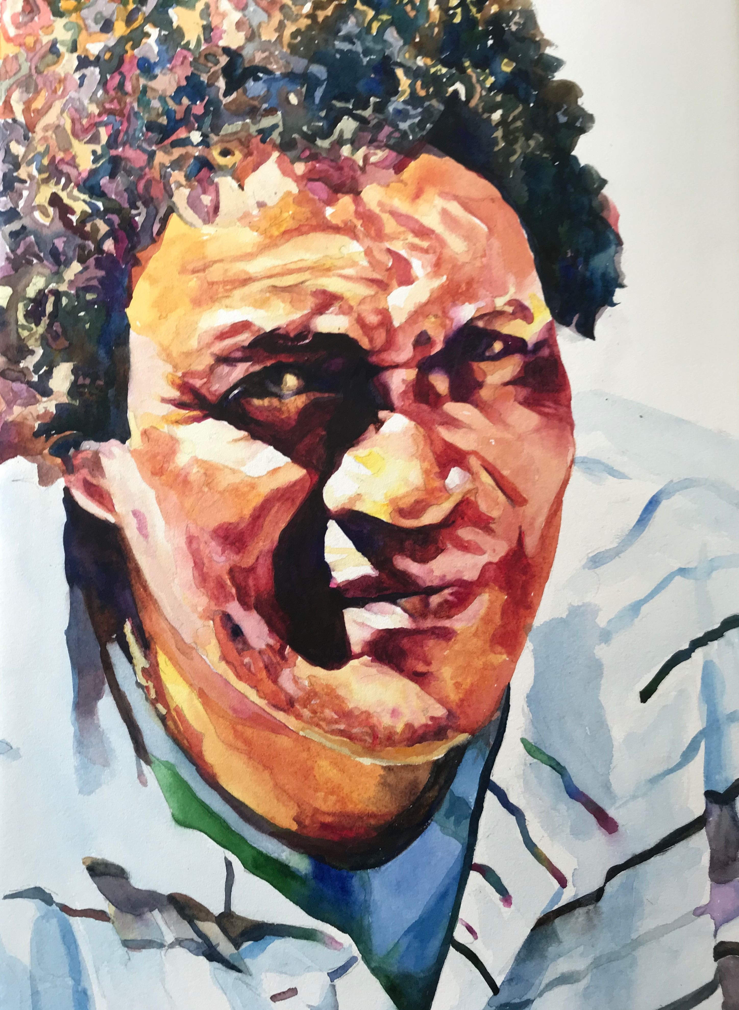
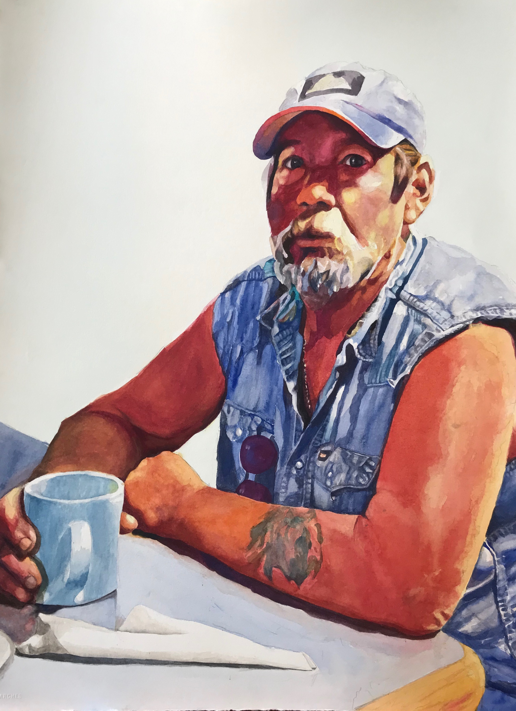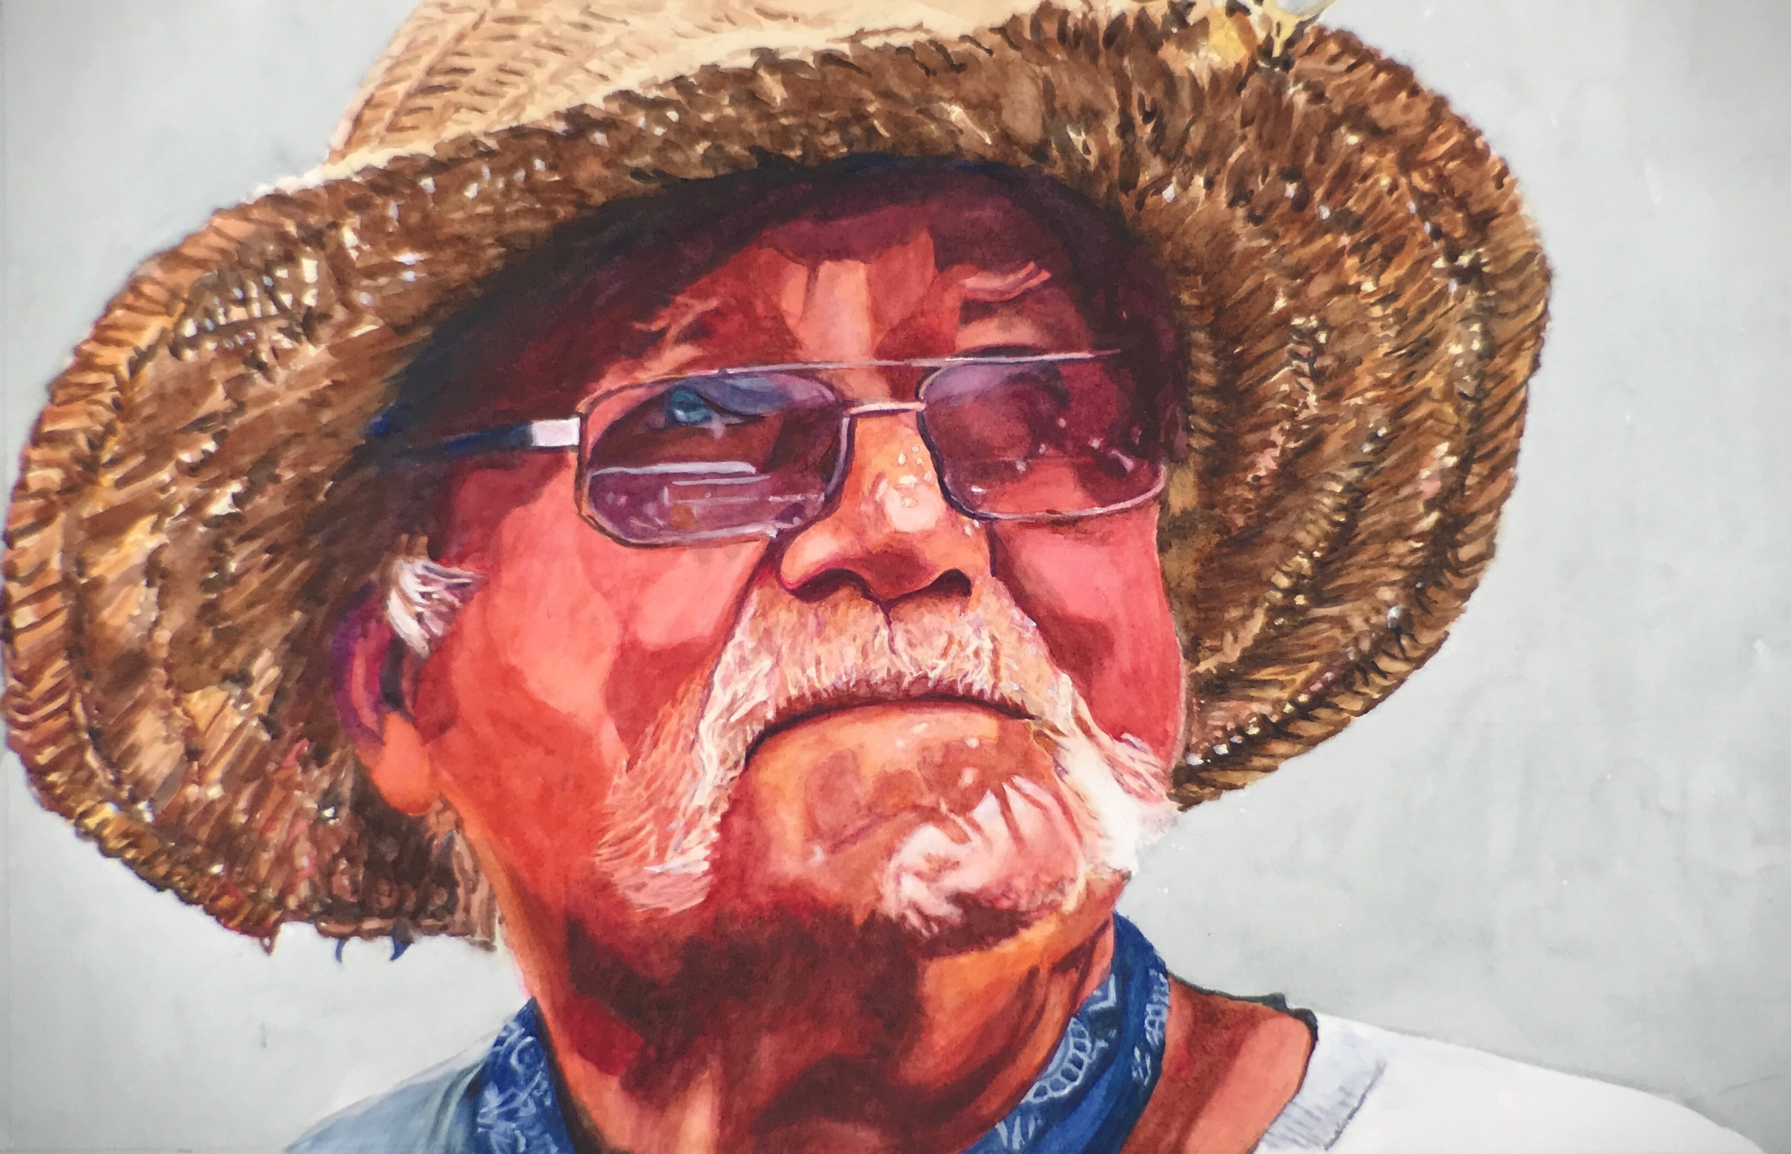

Ronald Malone
Portrait Artist

CONTACT
PHONE:
863-205-0345
ron@ronaldmalone.com
825 E Church St, Bartow FL 33830
www.ronaldmalone.com

